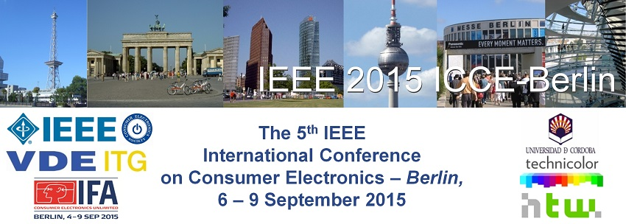
Patron Opportunities
The IEEE Consumer Electronics Society has long stood for the highest levels of technical achievement. ICCE maintains that tradition of excellence in the consumer electronics and networking space. Associating your brand with ICCE through patronage enhances your brand perception among a select group of the world's best scientists, engineers, and executives. The patronage packages listed below can help you showcase your brand's excellence to the IEEE-ICCE and the IFA (a partner of ICCE and VDE) community.
The IEEE International Conference on Consumer Electronics ICCE-Berlin is run in parallel with IFA and held inside IFA ground in Berlin. It attracts a global mix of industry and academic participants and is an excellent opportunity to promote your company/organization to an audience of world-class researchers in the CE industry.
If you have any questions, or would like us to customize a package just for your company, please contact Charlotte Kobert at ckobert@ieee.org or Francisco J. Bellido (IEEE 2015 ICCE Berlin Sponsoring Chair) at fjbellido@ieee.org
Diamond Patron (€ EUR)
- Logo on conference web site, with link to company's site or any page of company material
- Opportunity to suggest a keynote speaker for the conference
- Option to briefly address the attendees
- A full page color ad in the final conference program
- Patronage listing in final conference program to include brief company overview
- Prominent signage identifying company as a Diamond patron
- Acknowledgment in opening address
- Two full conference registrations
- Option to add promotional materials to the conference bag (must be approved by IEEE)
- One reserved table for ten at the conference banquet

Platinum Patron (€ EUR)
- Logo on conference web site, with link to company's site or any page of company material
- A full page black and white ad in the final conference program
- Patronage listing in final conference program to include brief company overview
- Prominent signage identifying company as a Platinum patron
- Acknowledgment in opening address
- Two full conference registrations
- Option to add promotional materials to the conference bag (must be approved by IEEE)
Gold Patron (€ EUR)
- Logo on conference web site, with link to company's site or any page of company material
- A half page black and white ad in the final conference program
- Patronage listing in final conference program to include brief company overview
- Prominent signage identifying company as a Gold patron
- Acknowledgment in opening address
- One full conference registration
Silver Patron (€ EUR)
- Logo on conference web site, with link to company's site or any page of company material
- A quarter page black and white ad in the final conference program
- Patronage listing in final conference program to include brief company overview
- Prominent signage identifying company as a Silver patron
- Acknowledgment in opening address

Other Patron Opportunities
- Wireless access for three days of the conference ( EUR)
- Industry products for prize drawings
- Free registration for attending to the conference.
- Explicit thanks & Mention in the Opening Session and Closing remarks.
- A 10 minutes interview for IEEE CE Soc. TV channel and add this interview to CE Soc TV channel.
- Install a small products demo desk during posters session.

